**DANANG SOFTWARE CORPORATION**

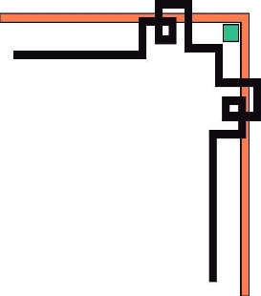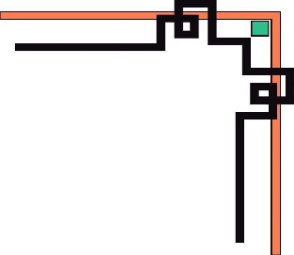

**SOFTECH-APTECH**



EProject :

MARINA FLEET

Guiding faculty : NGUYEN VIET HUYNH

Members :

* LE DUC HUY
* NGUYEN VAN ANH MINH

Group : 02

Batch : 155

**Da Nang, 15th November 2019**

Project Document

**MARINA FLEET**

|  |  |
| --- | --- |
| **Group 2** | |
| **Instructor** | Mr. Nguyen Viet Huynh |
| **Group Members** | Le Duc Huy (Leader)  Nguyen Van Anh Minh |
| **Batch** | 149 |
| **Semester** | 1 |

**TEACHER’S EVALUATION**

………………………………………………………………………………………………………………………………………………………………………………………………………………………………………………………………………………………………………………………………………………………………………………………………………………………………………………………………………………………………………………………………………………………………………………………………………………………………………………………………………………………………………………………………………………………………………………………………………………………………………………………………………………………………………………………………………………………………………………………………………………………………………………………………………………………………………………………………………………………………………………………………………………………………………………………………………………………………………………………………………………………………………………………………………………………………………………………………………………………………………………………………………………………………………………………………………………………………………………………………………………………………………………………………………………………………………………………………………………………………………………………………………………………………………………………………………………………………………………………………………………………………………………………………………………………………………………………………………………………………………………………………………………………………………………………………………………………………………………………………………………………………………………………………………………………………………………………………………………………………………………………………………………………………

**Table of Contents**

I. ACKNOWLEDGEMENTS 5

II. INTRODUCTION 5

III. PROBLEM DEFINITION 6

IV. USE CASE & SITE MAP & LAYOUT 7

1. Use case diagram 7

2. Site map 8

3. Layout 9

V. TECHNICAL 14

VI. REFERENCES 14

VII. GUI 15

VIII. PROJECT PLANNING 21

**I. ACKNOWLEDGEMENT.**

We would like to sincerely acknowledge the kindness of all the people who have given moral support and helped us make a successful project.

We wish to express our deep gratitude to the e-Project Team at the Head office, who guided and helped us. Particular thanks to **Ms.Nguyen Viet Huynh** who suggested the “form validation” and help us connect storage to our project, develop the analysis proceeding from it and debugged code. We also would like to express our great gratitude to all the student members of our center (Softech Aptech).

Although we have made many attempts, because of the limited time, the practice could not be able to avoid the mistakes and missions. We hope that our project will be considered and evaluated. And finally, we would like to offer many thanks to all our friends for their valuable suggestions and constructive feedbacks.

# II. INTRODUCTION

Here you can purchase different kinds of brands of air conditioners with suitable prices. We provide you large variety of air conditioners.Cosy employ our own installation teams who only work for Cosy. We buy direct from the manufacturer. We quote, We install, We guarantee it!

This guarantees you a quality assured job installed to the standards and guaranteed by Cosy. At Cosy, we go well beyond just quoting a shelf product or merely quoting from a plan. Cosy holds Standards Licence and is passionate about quality. As such, we are wholly committed to providing our customers with what they want… the best energy solutions available for their home environment!

**III. PROBLEM DENIFITION.**

1. **Homepage**

This is the page where user will be navigated to other main pages such as: Features, News, Events, Galerry.  
 There is a carousel that display some nice pictures which we collected from our customer.  
 In the footer, our commitment, some information about the company and navigated links to other social networkings like: Facebook, Twitter, Youtube…

1. **Feature page.**

Our products are categorized into 4 types: Luxury, Fishing, Sailing and Sport.

1. **News & Events pages.**

Those pages display many news, events that connect to our service in Da Nang and near by cities.

1. **Customers pages**

Those pages are used for customer to register or log in into our website. They can give us some information about them. Customers also can see their purchase history in My boats, where their receipts are display with some main details.

1. **About pages**

About us page presents many information about our company and our team. In this page, customer can see company’s address as both text and API-Google map. There is a contact form that customers can send email to us.

**IV. USER CASE & SITE MAP & LAYOUT**

1. **Use case**

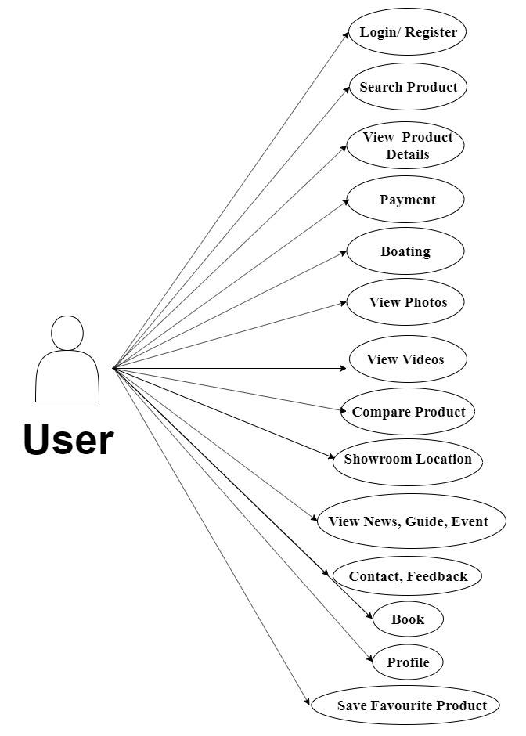

1. **Site map**

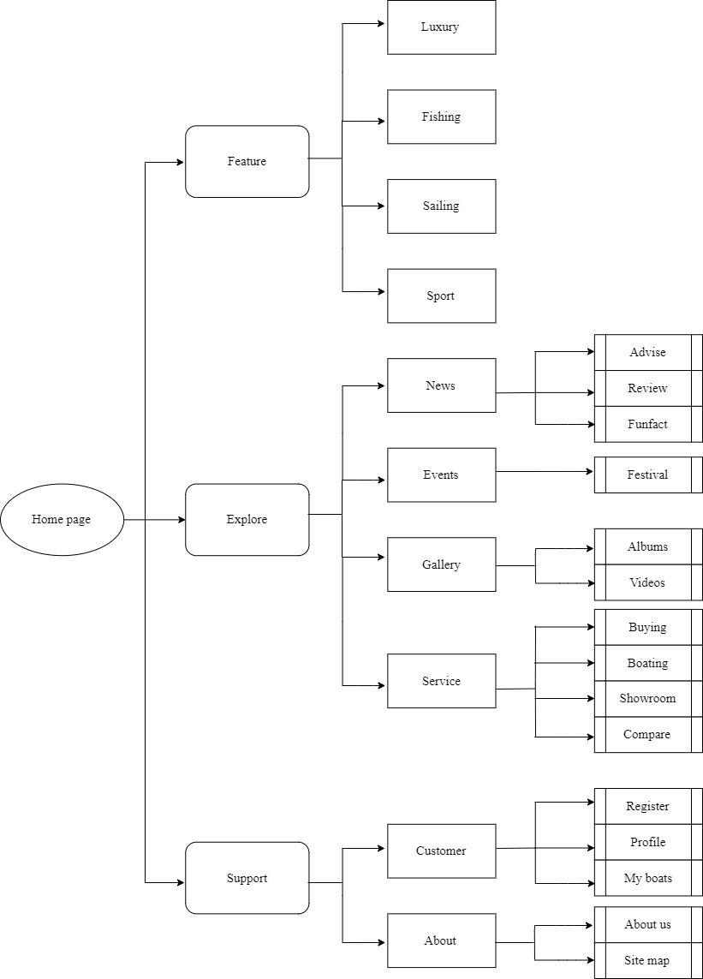

1. **Layout**

**a/ Home page layout** 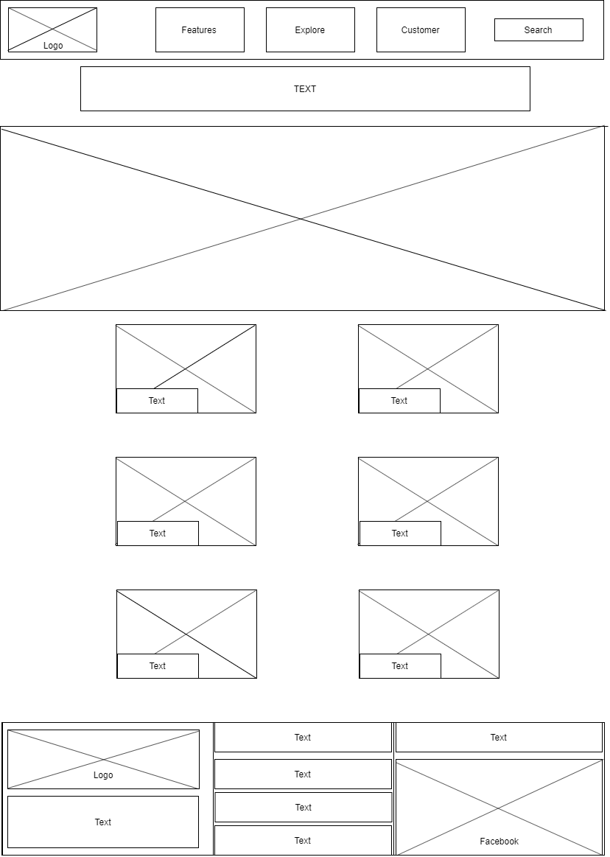

**b/ Feature page layout**

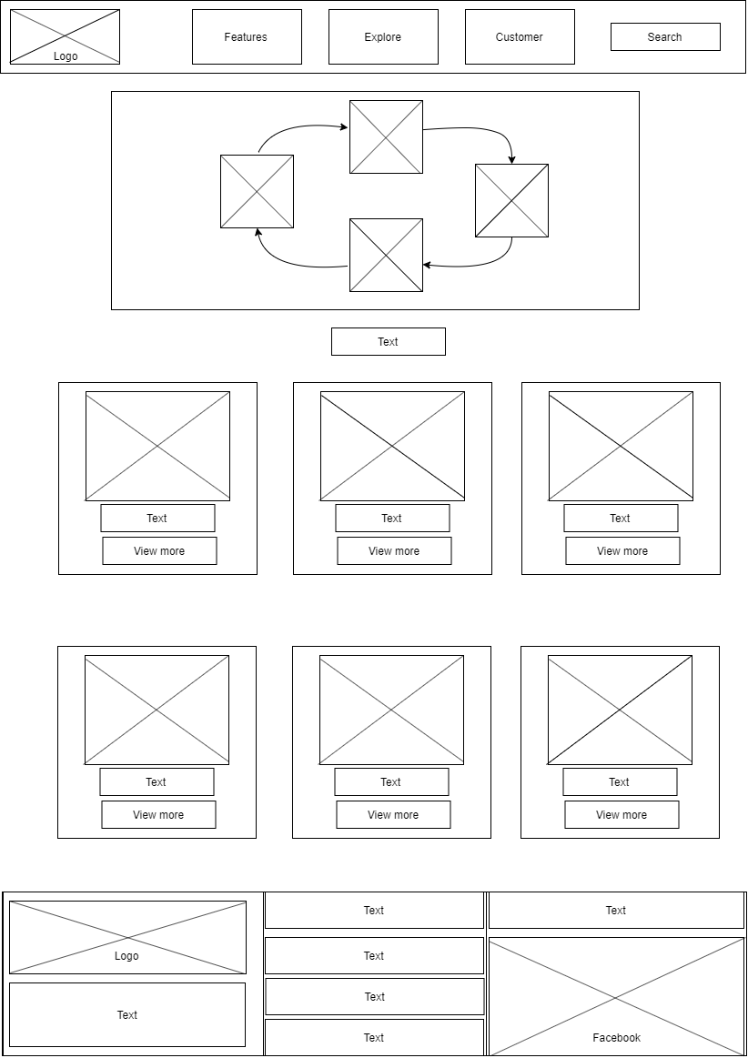

**c/ News & Events pages layout**

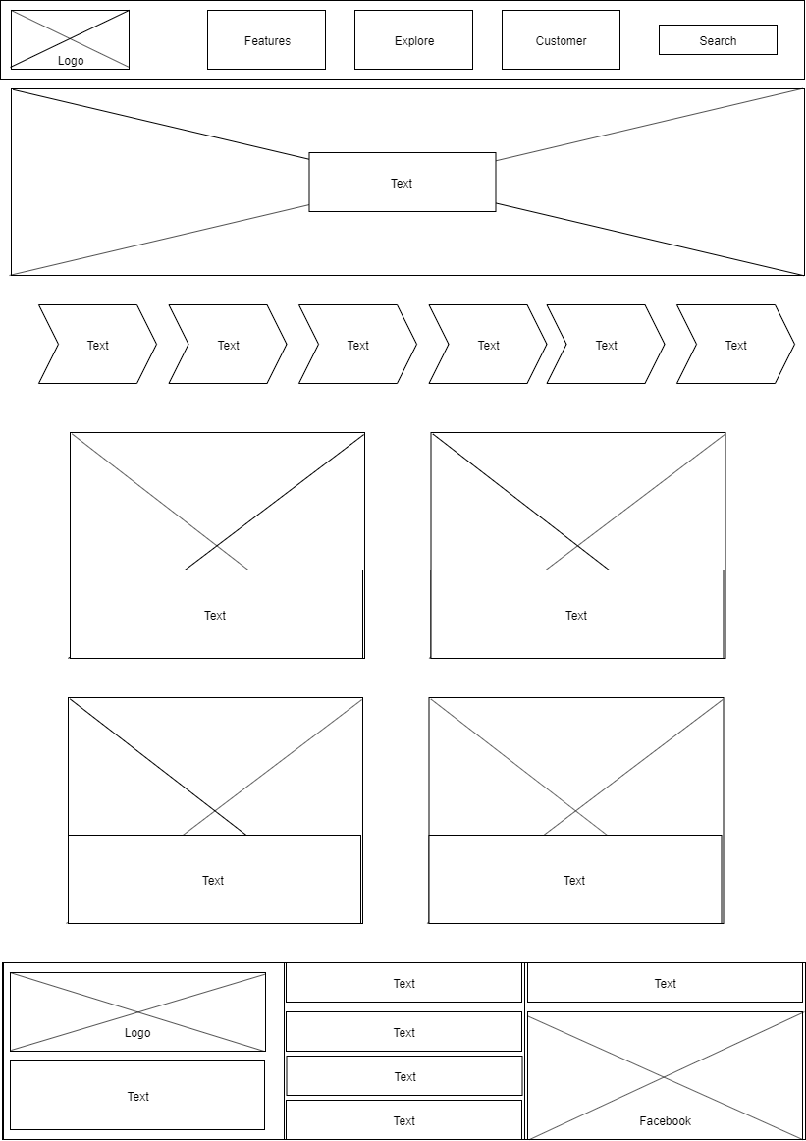

**d/ My boats layout**

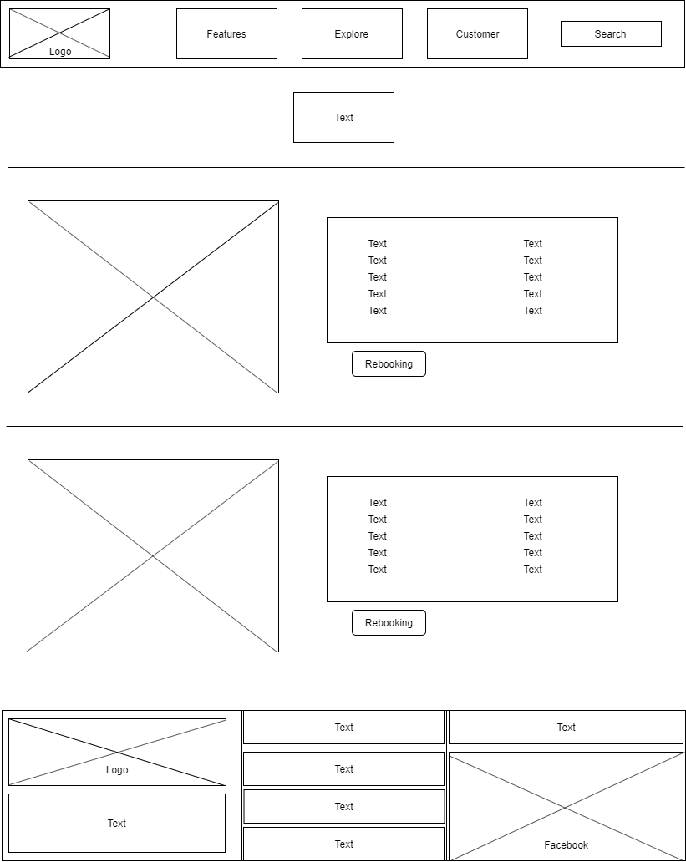

**e/ About page**

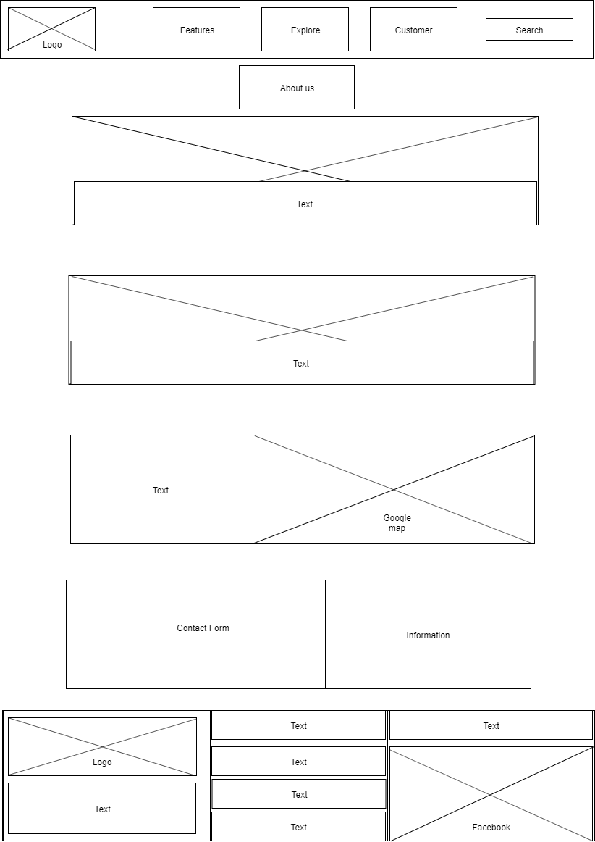

# V. TECHNICAL

Software: WebStorm

Web Browser: Blisk, Chrome, Firefox support design Responsive

The technique used to build the Website:

* HTML5 & CSS3.
* Bootstrap
* JQuery & JavaScript.
* Bootstrap form helpers.
* Horizontal fixed navigation.
* Material for bootstrap:
* BootStrap Carousel.
* Button.
* Form.
* Glyphicon
* Navbar
* …….
* …….

# VI. REFERENCES

We consulted information on the websites:

* [**https://w3schools.com/**](https://w3schools.com/)
* [**https://jquery.com/**](https://jquery.com/)
* [**http://www.getbootstrap.com/**](http://www.getbootstrap.com/)
* [**http://www.fonts.googleapis.com/**](http://www.fonts.googleapis.com/)
* [**https://pixabay.com/**](https://pixabay.com/)

**VII. GUI**

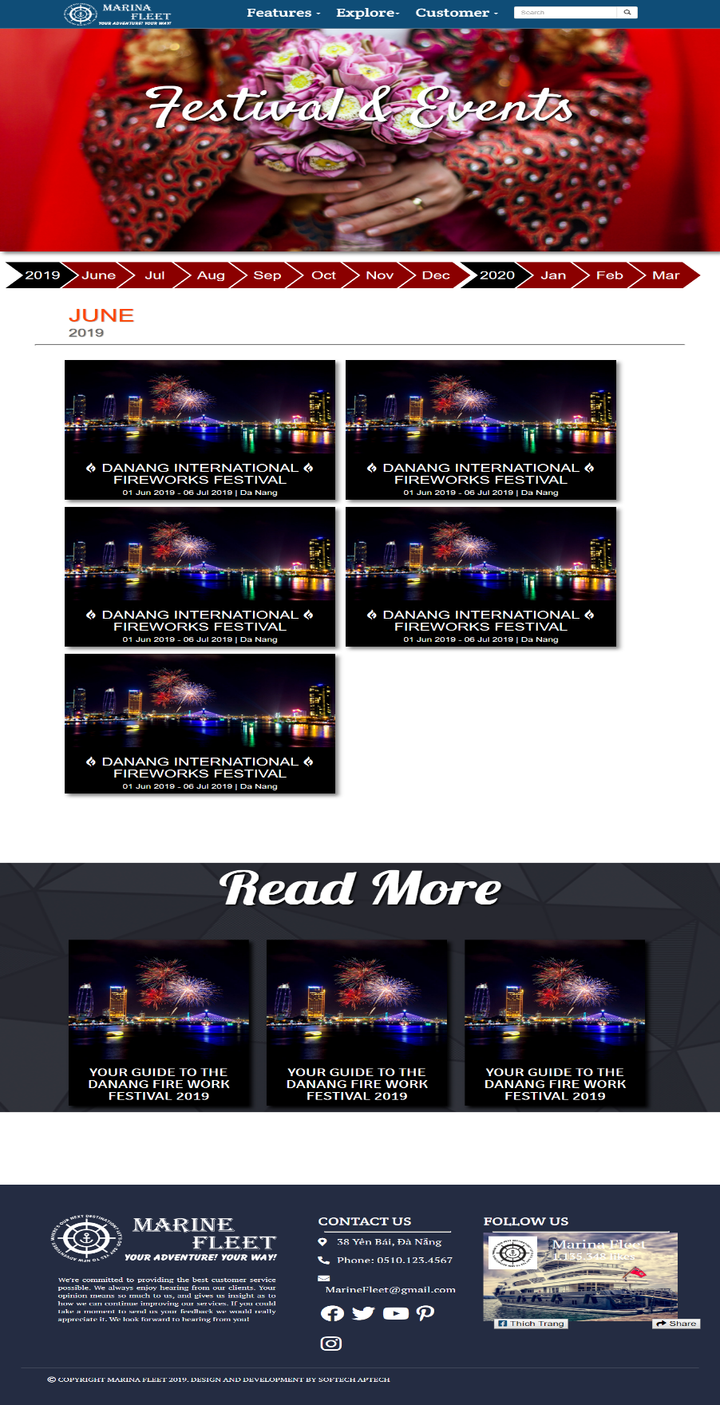**Event page:**

**Customer- Profile**

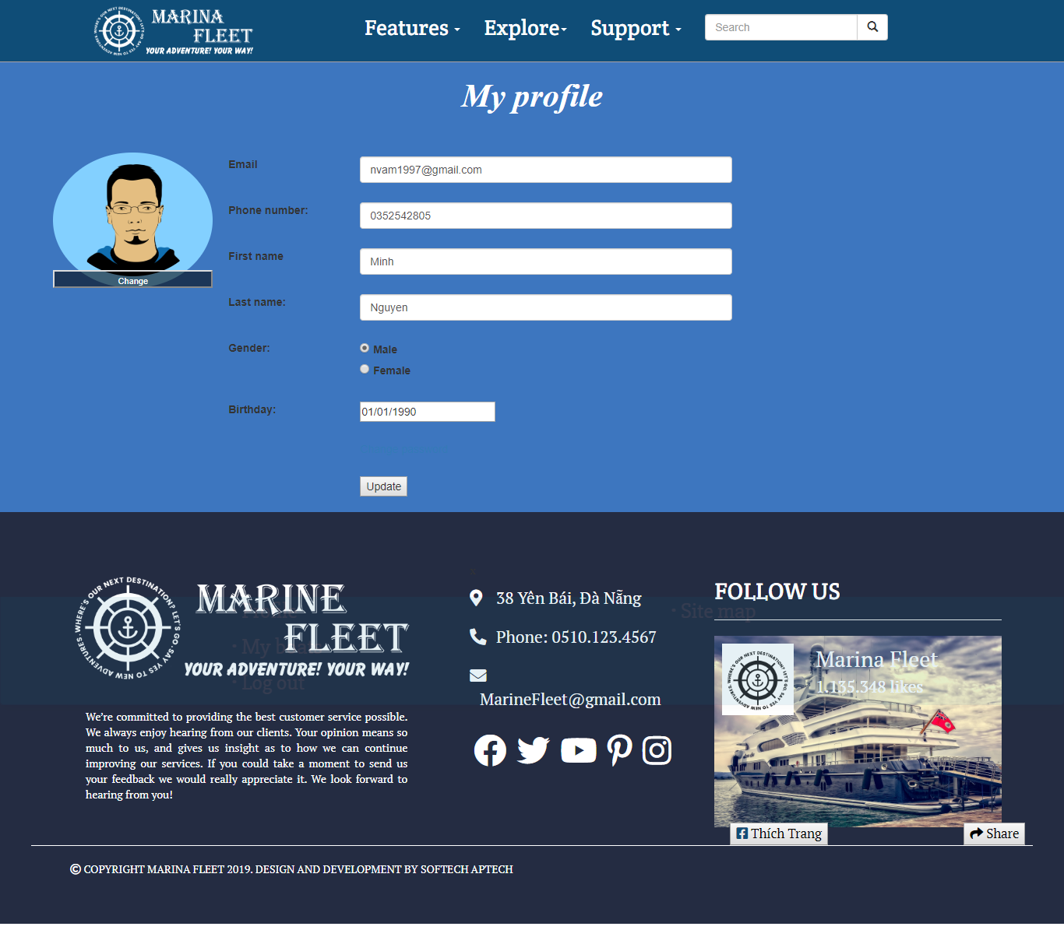

**Customer – My boats**

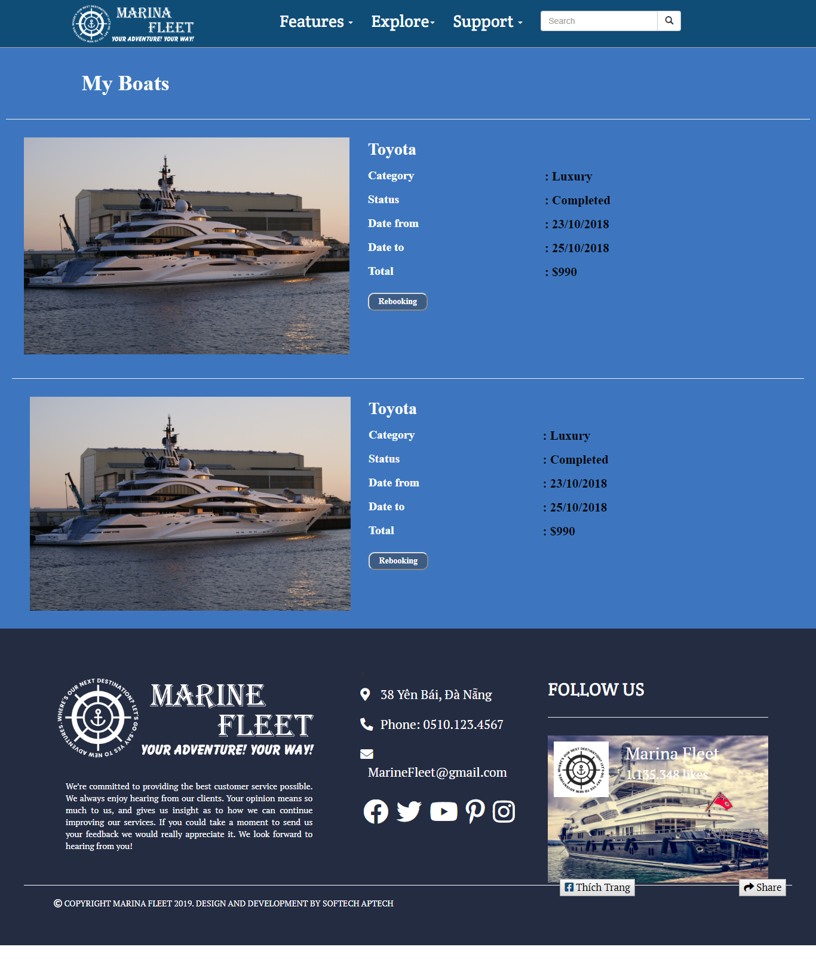

**About us**

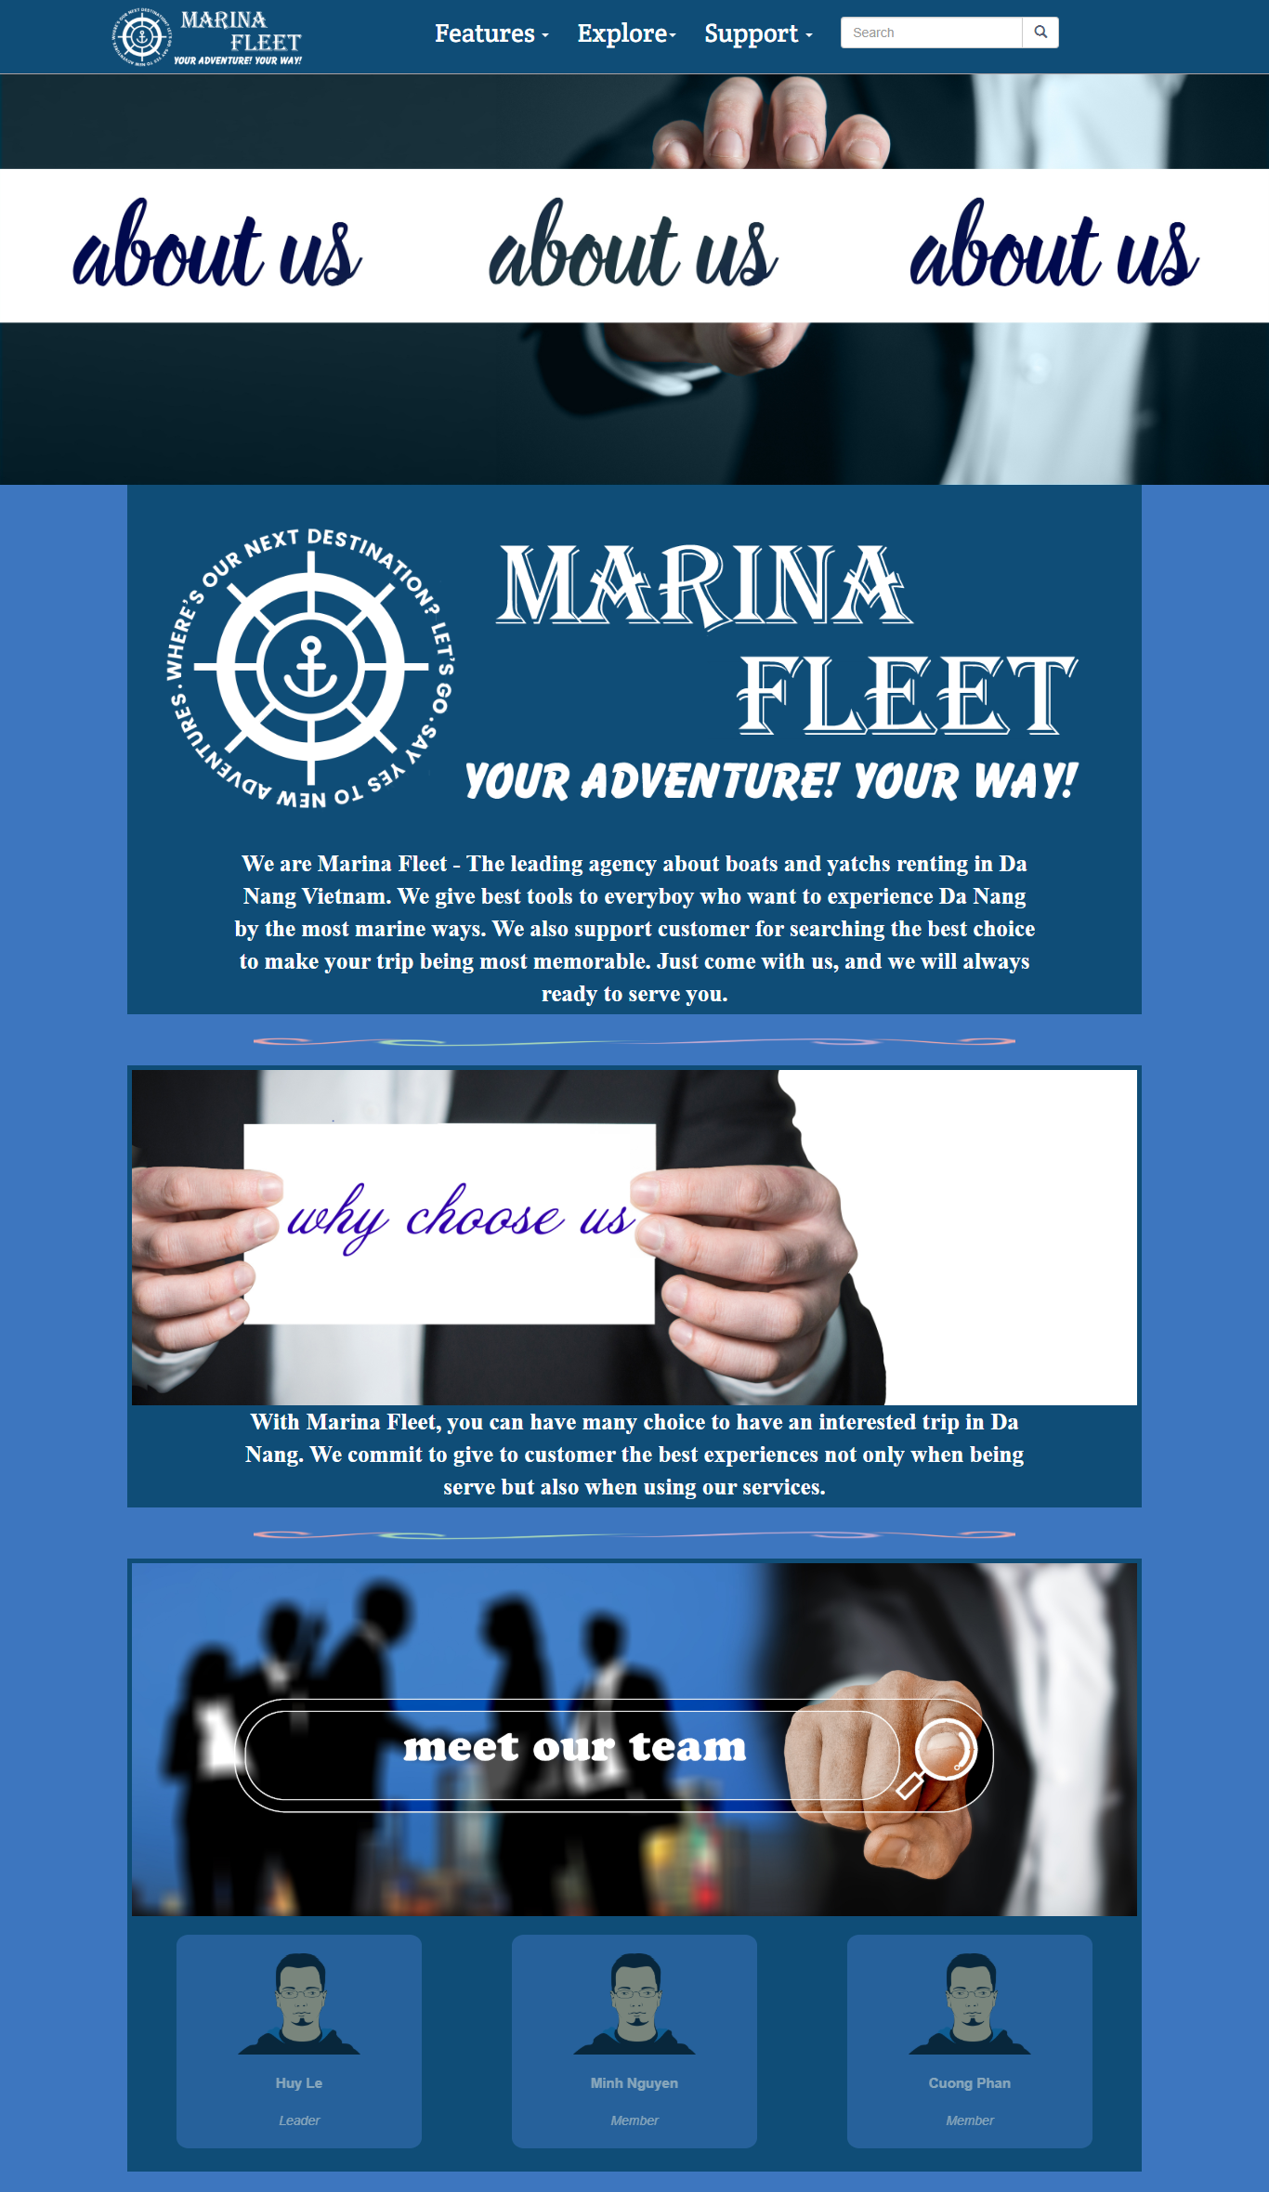

**About us(2)**

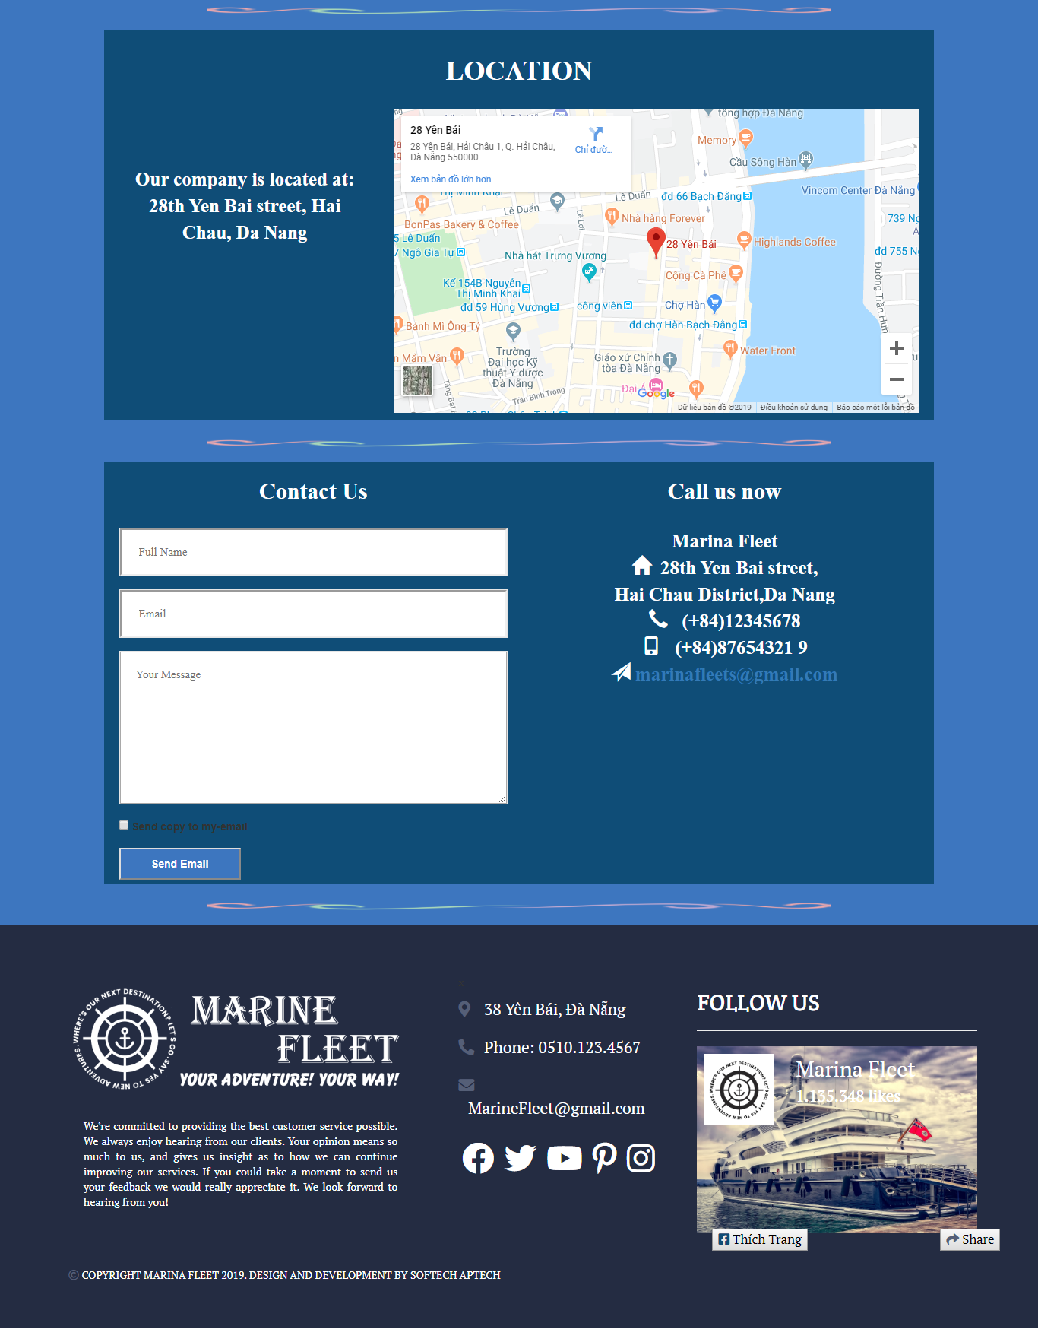

**Site map**

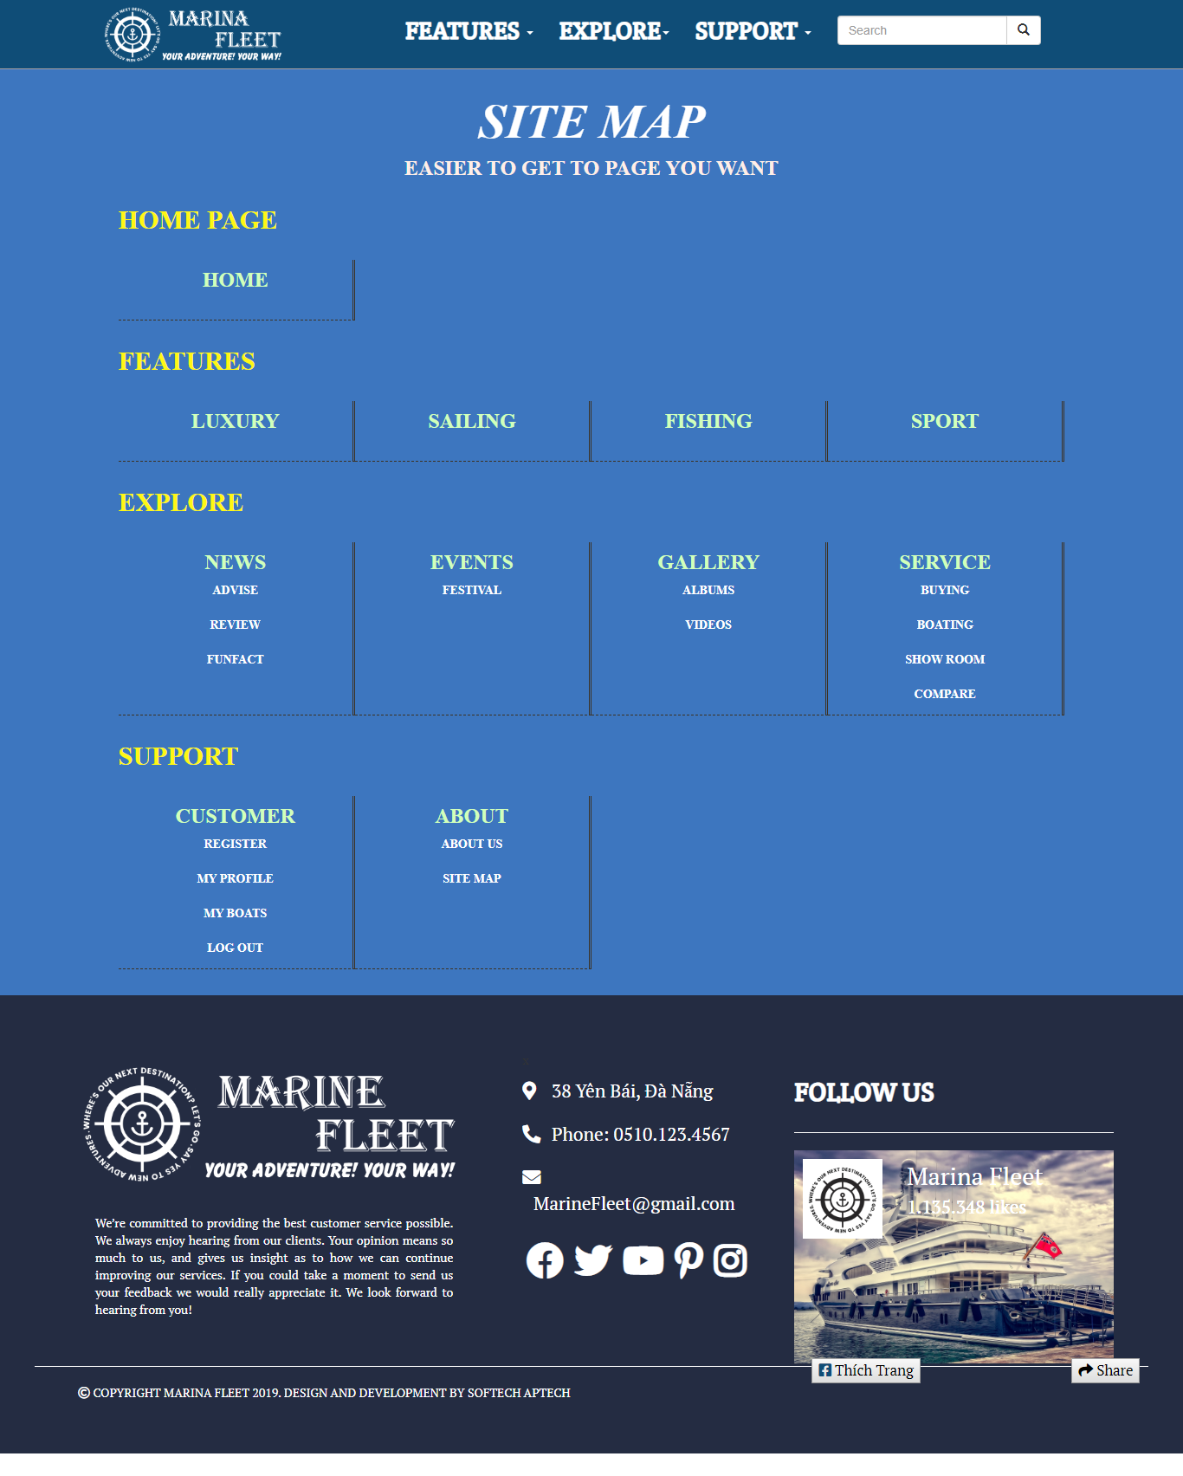

**VIII. PROJECT PLANNING**

|  |  |  |  |  |  |  |
| --- | --- | --- | --- | --- | --- | --- |
| ***NO.*** | **TASK** | **BEGIN** | **END** | **MEMBER** | **LEVEL** | **STATUS** |
| ***1.*** | Analyzing | 25/09 | 25/09 | All | High | Finished |
| ***2.*** | Planning | 27/09 | 27/09 | All | High | Finished |
| ***3.*** | Designing | 28/09 | 28/09 | All | High | Finished |
| ***4.*** | Searching materials | 30/09 | 10/10 | All | Medium | Finished |
| ***5.*** | Home page | 01/10 | 05/10 | Huy | High | Finished |
| ***6.*** | News/Events | 01/10 | 05/10 | Huy | Medium | Finished |
| ***7.*** | Features | 06/10 | 10/10 | Huy | Medium | Finished |
| ***8.*** | Gallery/Service | 06/10 | 10/10 | Huy | Medium | Finished |
| ***9.*** | Customer | 01/10 | 05/10 | Minh | High | Finished |
| ***10.*** | About | 06/20 | 10/10 | Minh | Medium | Finished |
| ***11.*** | Add up codes and sources | 11/10 | 12/10 | Minh | High | Finished |
| ***12.*** | Complete and correct website | 13/10 | 15/10 | Huy | High | Finished |
| ***13.*** | Writing Document | 16/10 | 18/10 | Minh | Medium | Finished |